**Digital Culture Assignment 3 – Synopsis***By Marcus Thomas Due Jensen*

**”Reusing the Digital – From Product to Waste”**

Digital artifacts are undergoing a long lifecycle, from production to degradation. As a consumer, we don’t follow the products in their linear lifecycle. Instead, we only experience different fragmented parts of the lifecycle. This nonlinear experience of the lifecycle of digital artifacts, may lead to a misinterpretation and understanding of the digital artifacts that we surround ourselves with. There is a mindset of limitless availability around digital artifacts. When a mobile phone or computer breaks, we can just buy a new one without other consequences than economic. However, our products are part of a long line of reused materials, from the commercial products themselves, to their software and hardware, and finally to how they are recycled. Therefore, this notion begs to ask the question:

*How can the circle of culture assist as a tool to unravel the different aspects of how digital artifacts are getting reused through their lifetime, and what will this awareness mean for the average person?*

In this synopsis I will use the circle of culture as a tool around four different aspects of the lifetime of digital artifacts. These four points are the commercial product, the software, the hardware, and the waste. I have made a collection of four objects, that represent these four different stages in the lifetime of digital artifacts. These objects are: The Personal Computer, The P5.js programming Library, DIY Prosthetic Arm and finally E-Waste art by Benjamin Von Wong. The objects each represent and illustrate different approaches of reusability within Digital Artifacts. The collection of objects can be found on a website I have build myself, based on code from earlier projects, to further illustrate the point of reusability within digital culture.

**Method**

The circle of culture and its five different aspects will be applied to the individual objects. The goal is to investigate how the different points of the circle of culture can relate to the different aspects of the journey of the digital. The journey can both be seen as the direct path of life a digital object has, but also in the sense of how

All the objects contain all the elements of the circle of culture to some degree. However, it is interesting to see the circle of culture as a temporal journey of the digital. What new insights then emerge?

**Consumption - The Personal Computer:** The Consumption aspect of the circle of culture has strong ties to The Personal Computer. The PC is a commercial product that the actively purchases. The consumer has to choose between the different models presented to them. Many different models exist, based on preference of brand, power, price and the like. Manufactures and salesmen of Personal Computers typically base their models and marketing on earlier products from them. The Personal Computer is evolving based on inheriting factors of earlier models. Depending on what models get consumed the most by the population, the manufacturers will typically replicate – or reuse – the same qualities in newer models, to guarantee sales. In this sense, reusing the digital is about consumption.

**Signification - P5.js:** Signification has many similarities to P5.js. can relate to signification, as visual programming is about signifying something specific. It is about representing ideas and directions of the programmer. In the sense of reusability, it isn’t unordinary for programmers to base their software on example code and suggestions on forums made by other programmers. Code and software is constantly getting reused to construct new and interesting digital artifacts. In a sense, programmers use other programmers’ signification to shape their own signification, through amalgamation of different ideas and software snippets. In this sense, reusing the digital is about signification.

**Production - DIY Prosthetic Arm:** The DIY Prosthetic Arm is very relatable to the Production element of the circle of culture. It is about making, fabricating, constructing something new. For example the DIY prosthetic arm is build upon 3d-printing technologies and a microcontroller. The 3d files for the prosthetic arm might be designed by someone else, but the maker can reuse the files and adjust them for themselves. Furthermore, the microcontroller might have been used for other projects earlier, or may be used for other projects in the future. Therefore the actual hardware components are reused. In addition, some DIY Makers cannibalize old PCs from usable components, and effectively reuse the parts of commercial products. Therefore, reusability is also a central element within the hardware domain of digital artifacts. In this sense, reusing the digital is about production.

**Regulation - E-Waste art by Benjamin Von Wong:** The E-Waste artworks by Benjamin Von Wong illustrates greatly how E-Waste and to an extension E-recycling can relate to regulation within the circle of culture. The artworks are made as a wakeup call to get the general public to react to the increasingly E-Waste problem in the world. More or less all western countries ship of their waste, as they can’t process it all. There aren’t regulations in place that enforce the recyclement of electronic waste. Few countries are required by law to process their own waste. In this sense, reusing the digital is about regulation.

**Identity – Collection:** Identity is in a sense a umbrella-term, that is overarching all the objects in the collection. Throughout the journey of degeneration and reuse of a digital artifact, the identity of the user change. In all the different aspects, the identity of the culture is different. In a sense, the identity of the person who are related to the digital artifact, mirrors the cultural domain that the artifact is within. When the digital artifact is made for consumption, like a commercial product, the identity of the person becomes that of the consumer. When the digital artifact is about signification, the identity of the person becomes to signify ideas and thoughts. The digital artifact is then an extension of the identity of the person. In production, the person becomes a producer of digital artifacts. The person is the maker. Finally, in regulation, the identity of the person connected to the digital artifact becomes more regulatory. It is about making a change, or at least attempting to.

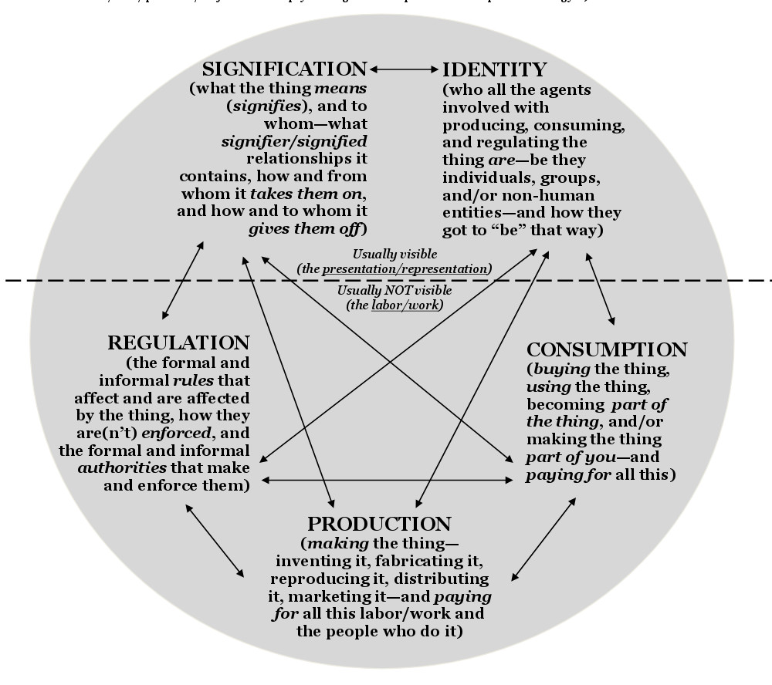

**Main points of discussion**

**Reusing – Physical or Ephemeral**

There are two central abstractions of reusability in digital culture. Physical or traditional reusability, in opposition to ephemeral reusability. Physical reusability can be described as reusability where a physical thing is used for another purpose, for example hardware in DIY culture, or the raw materials and metals in E-Recycling. Ephemeral reusability is reusing digital elements that doesent have a physical aspect. They are ephemeral. This could be the case of reusing code and software in programming. However, one could argue that the personal computer, in a sense, also is a ephemeral reused digital artifact. The way that personal computers have evolved through time, is a form of reusability, build upon older design ideas and constructions. The actual physical computer isn’t reused, but the idea and concept is.

Another interesting aspect, in the dynamics between physical and ephemeral reusability, is the fact that physical reusability is constrained in physical space. To be able to reuse hardware or raw materials, you need to physically use them. Therefore a single specific electronic component can only be used in one digital artifact at a time. This is contradictory to the reusability of ephemeral artifacts. When reusing software or code snippets, these aren’t constrained to a single use case. Programmers can copy/paste the same code snippets to a potentially unlimited number of different programs.

**Circle of culture as a tool**

The circle of culture can be applied to the lifecycle of digital artifacts. When using such a tool, it is both unraveling new insights but also constraining others. In this synopsis I have argued that the different aspects of the lifecycle of digital artifacts can be applied to the different points in the circle of culture. However, one could argue, that all the objects individually possesses all the points represented in the circle of culture. For example, as argued earlier, the personal computer can be related specifically to the consumption part of the circle of culture. However, it also represents aspects of all the other parts of the circle. In another analysis and interpretations of the personal computer, the use of Signification, Regulation, Production or Identity may be more appropriate for rewarding insights.

**Bibliography**

* Cramer, F. (2019). Does DIY mean anything? - A DIY attempt (=essay). Anrikningsverket Journal, (#1: Convulsion), 52–72.
* Gabrys, J. (2011). Introduction: A Natural History of Electronics. In *A Natural History of Electronics*. *Digital*
* Mitchell, S. (2018). Narratives of Resistance and Repair in Consumer Society. Third Text, 32(1), 55–67.
* Raymond Williams (1974), “Culture” in Keywords: A vocabulary of culture and society, 2014.